FINAL REPORT FOR MAIN PROJECT

SEARCH AND RESCUE ROVER (WALL-E)

DAVID KOBLAH: LEAD SOFTWARE PROGRAMMER

MARIO MARTINEZ: DESIGNER

ALIZÉ MORRIS: LEAD HARDWARE MANAGER

BINH LE: PROJECT MANAGER

DEPARTMENT OF ELECTRICAL ENGINEERING

MAY, 2017.

ABSTRACT

This paper is a detailed account of the various parts, processes and findings involved in designing and building the autonomous rover (named Wall-E). The finished robot was required to detect and move in the direction of pre-selected sounds of varying frequencies. At the source of the sound, the robot was to identify the specific sound using different pre-assigned LED colors. The project was quite arduous, but extremely educative. This project group utilized a distinct method of detecting sound. Although it did not function adequately on the demonstration day, the development of an alternative sound location method could be pursued by subsequent students assigned a similar project. It will be described in the subsequent chapters of this report.

ACKNOWLEDGEMENTS

The following individuals and groups were very instrumental in the process of developing the project:

Project Group 9

Binh Le, Mario Martinez, Alizé Morris

Funding

Department Of Electrical Engineering, Texas Tech University

Facilities Accessed

Laboratory Room 007

Tutoring

Dr David Hemmert, Daniel Ayala, Nathan Fryar

Others

Alan Estrada, Marti Hands, Weston Salinas, Derek Rangel Amador, Elissa Lindquist-Sher, Tony Kahumbu, Dr Stephen Bayne, Jennifer Maddox, Jaxom Hartman, Victor Obiri

TABLE OF CONTENTS

* Abstract…………………………………………………………………………. 1
* Acknowledgements……………………………………………………………... 2
* Table Of Contents……………………………………………………………….. 3
* Introduction……………………………………………………………………… 4
* Body
* Preamble…………………………………………………………………….. 5
* Rover Design ………………………………………………………………... 6-7
* Current Detection Circuit ……….…………………………………………... 8-9
* Sound Detection Circuit ……………………………………………………. 10-12
* HS-422 Servo Motor ………………………………………………………... 13-14
* Inductive Sensing Circuit …………………………………………………….15-16
* LED Circuit …………………………………………………………………. 17
* Pulse Width Modulation Module
  + - Rover 5 Motor ………………………………………………. 18-19
    - Hs-422 Deluxe Servo Motor………………………………… 20-21
* Current Detection Response Module………………………………………... 22-23
* Sound Location Module ……………………………………………………. 24-27
* Inductive Sensing Module ………………………………………………..… 28
* Results………………………………………………………………………. 29
* Conclusion…………………………………………………………………... 30
* References…………………………………………………………………… 31
* Appendices…………………………………………………………………… 32-35

INTRODUCTION

Like many projects the Department of Electrical Engineering has assigned, the automated rescue rover has many direct applications to real-life situations. Applying human senses to our robots would mean locating different targets. They could range from human beings, to even land mines buried underground.

The Wall-E project could simply be described as a pioneer in the field of frequency detection and sound location. It was meant to utilize the servo motor to identify and follow the source of sound, which was different from the conventional phase-difference method. The scanning sequence of the servo motor would mean fixed directions and movement. In a more sophisticated undertaking, the servo motor could be used to map out an entire field.

Although the project had many shortcomings, there is no doubt that the idea of Wall-E will serve future generations of electrical engineering students who may be given a similar rubric.

PREAMBLE

Project Wall-E was divided into two sections:

1. Hardware Components
   * + - 1. Rover Body and Design
         2. Current Detection Circuit
         3. Sound Detection Circuit
         4. HS-422 Deluxe Servo Motor
         5. Light Identification Circuit
         6. Inductive Sensing Circuit
         7. LED Circuit
2. Software Components
   1. Pulse Width Modulation For Motor Movement
      1. Rover 5 Motor
      2. HS-422 Deluxe Servo Motor
   2. Frequency Counter Module
   3. Current Detection Response Module
   4. Sound Localization Module
   5. Inductive Sensing Module
   6. LED Identification Module

ROVER 5 DESIGN

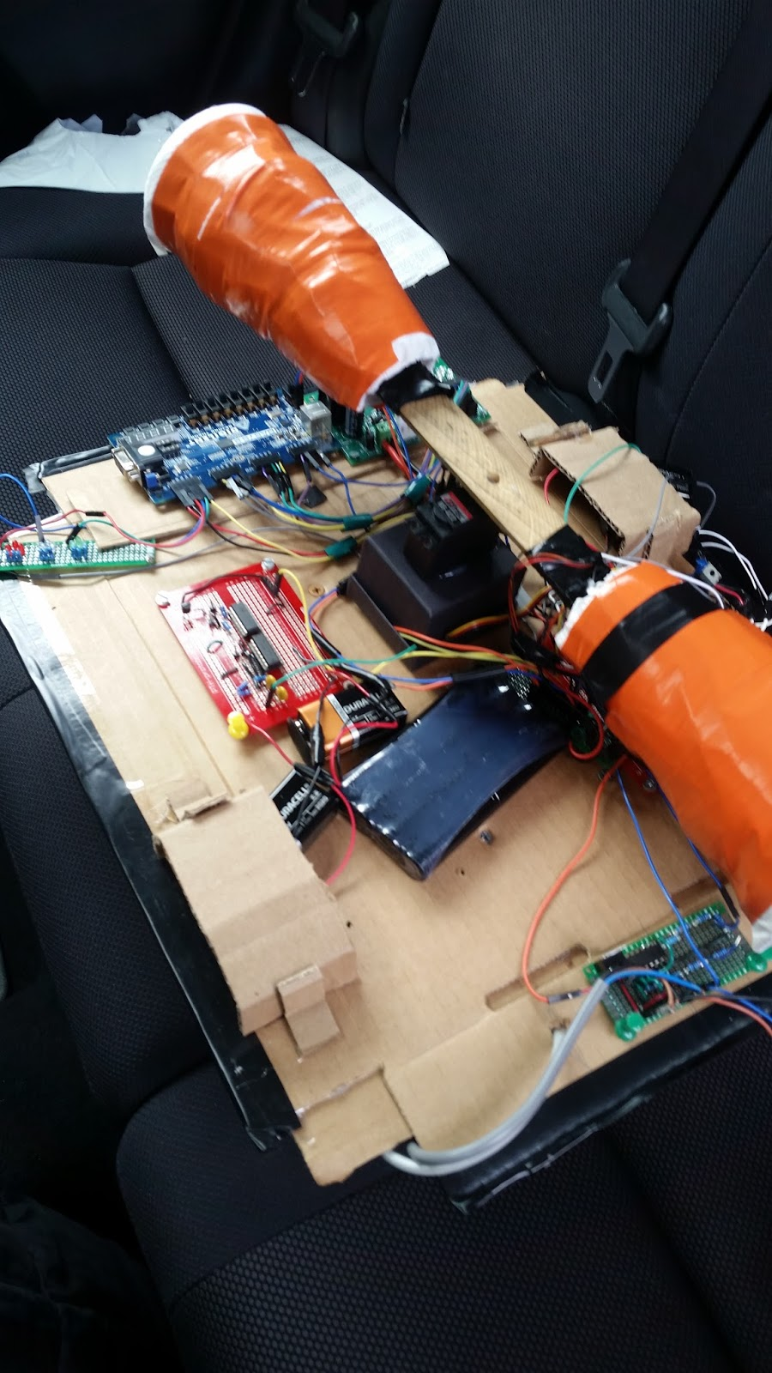

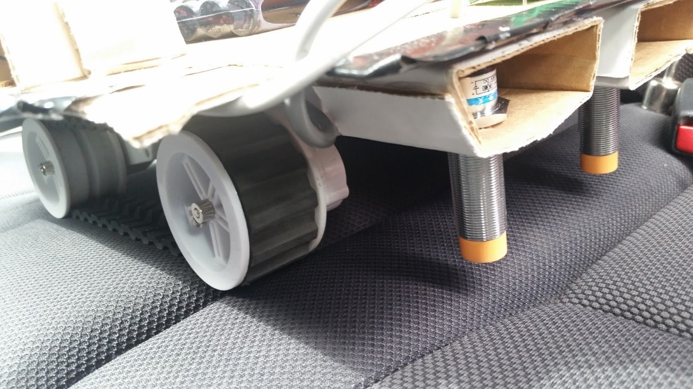

Figure 1.2: Bottom View of Rover with IP Sensors

Figure 1.1: Top View of Rover with Circuits

**SPECIFICATIONS:**

Motor rated voltage: 7.2 V

Motor stall current: 2.5 A

Output shaft stall torque: 10 kg/cm

Gearbox ratio: 86.8:1

Encoder type: quadrature

Encoder resolution: 1000 state changes per 3 wheel rotations

Speed: 1km/hr

An upper base of recycled cardboard was fitted onto the rover to provide enough space and easy access for various circuits. The Servo motor was mounted at the center of the cardboard base. An extra covering was constructed in the fashion of a car’s bonnet to protect the circuits from external damage.

CURRENT DETECTION CIRCUIT

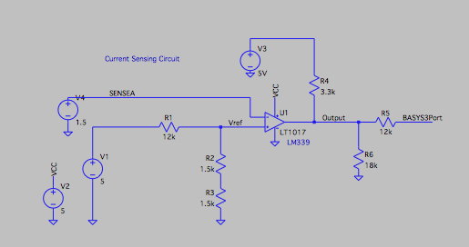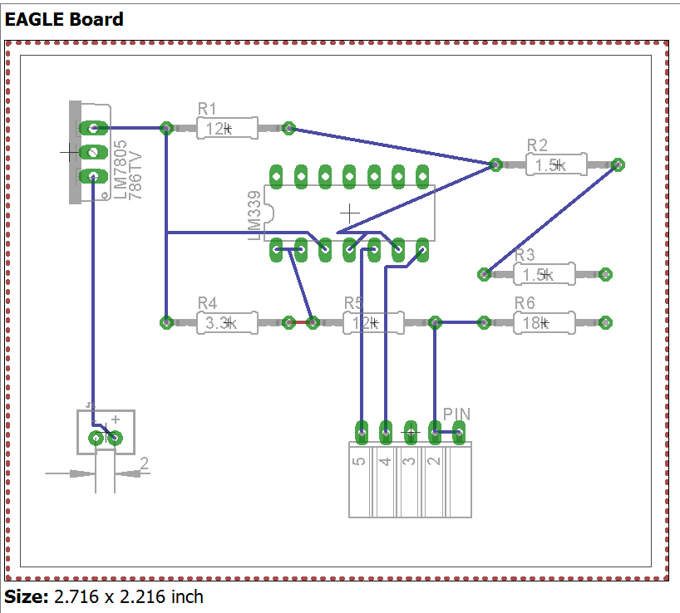

Figure 1.3: PCB Design of Current Detector Circuit

Figure 1.4: Schematic of Current Detector Circuit

The purpose of the current detection circuit is to send a signal to the BASYS board when the currents driving the rover 5 motors exceed 1 amp. The main component of the circuit is the LM 339 integrated circuit operating as a comparator operational amplifier.

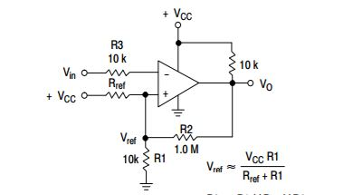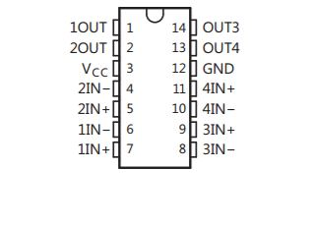

Figure 1.6: Operational Amplifier as Comparator

Figure 1.5: LM 339 IC Schematic from datasheet

The LM339 provide a separate op amp for each motor. The H-bridge circuit has a current sensing pin for each motor. The wires from the current sensing pins are connected to each of the two non-inverting inputs of the LM339 IC. A reference voltage of 1V was set up using voltage division of the 5V threshold voltage. This sent a signal to the BASYS board for a response. The voltage output from the comparator was pulled up by a resistor connected to the supply. Voltage division reduced the output voltage to suitable levels for the BASYS Board. The required response was to stop the rover for one second.

The Current Sensing Circuit was built on Eagle CAD, but due to an error, the backup soldered version was used in the final design.

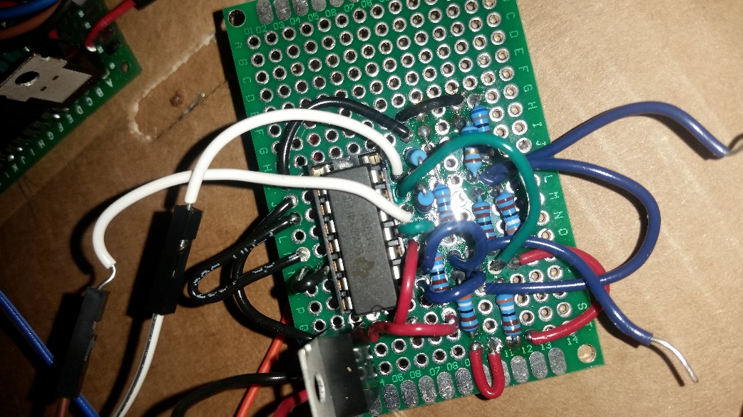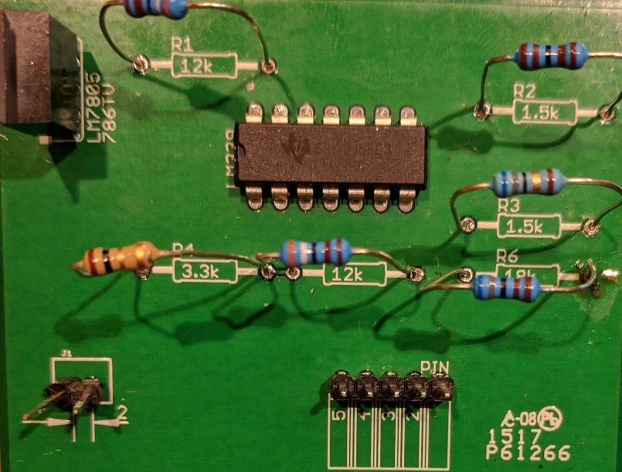

Figure 1.8: Replacement Current Sensing Circuit

Figure 1.7: Faulty PCB Version of Current Sensing Circuit

SOUND DETECTION CIRCUIT

Figure 1.9: Band-Pass Filter Flow Chart

The microphones had to be occasionally tested to make sure they were working. They were very fragile, with any voltage surge or instance of overuse causing them to burn out.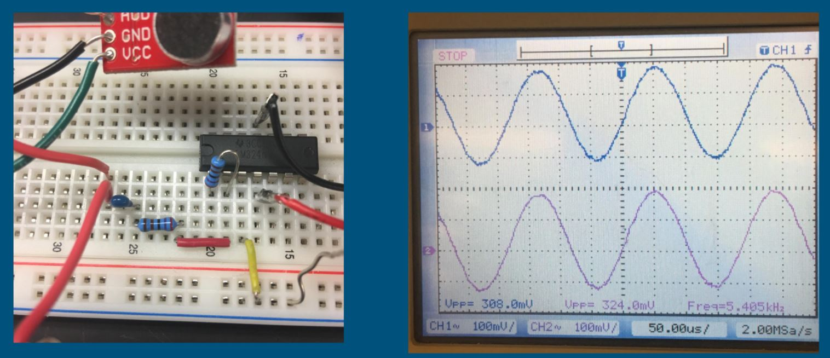

Figure 1.10: Basic Microphone in operation

The microphones used for the project had their own operating frequency range (100Hz - 10 kHz) due to a built-in low-pass filter. The band-pass filter chart shown in Figure … explains the method of creating frequency range of operation for the circuit.

The soldered circuit below (Figure 1.11) shows the band pass filter connected to the rest of the circuitry. The LM 324 IC was used to set up the band pass filter (Figure....). The diagram in Figure …. Shows the set-up of the first order high pass filter while Figure … shows the result of 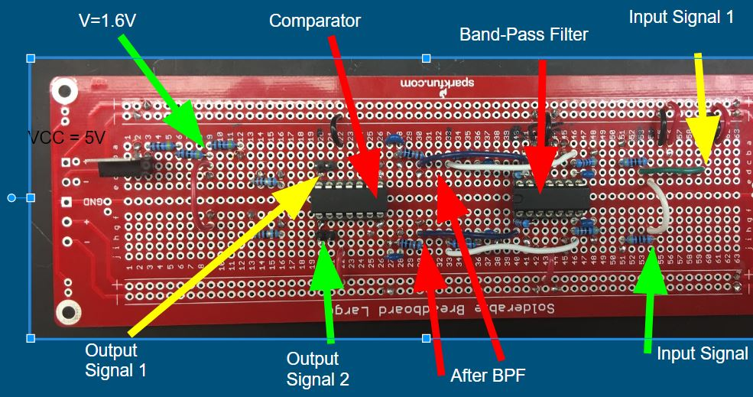the filter using a simulation.

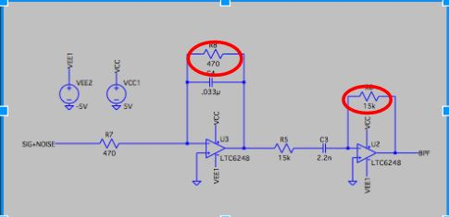

Figure 1.11: Sound Circuit

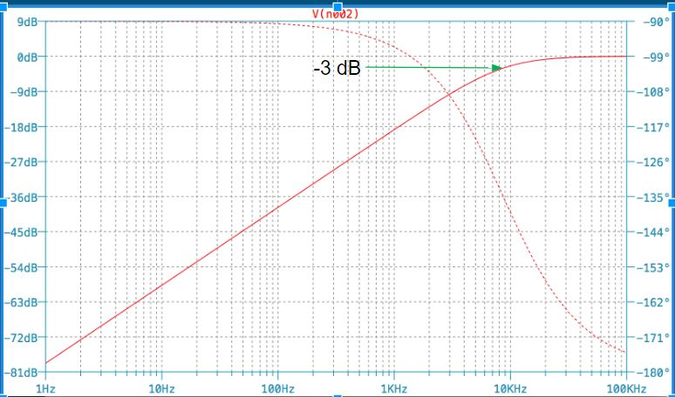

Figure 1.12: LT Spice Model of Band Pass Filter

Figure 1.13: Result of Filter with -3dB point Showing Cutoff Point

Comparator

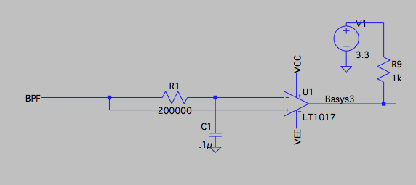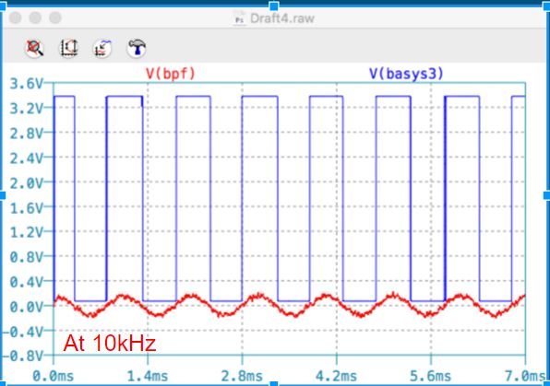The purpose of the comparator was to convert sinusoidal waves to square waves. This was done using an LM339 IC. A DC offset within the microphones had to be accounted for.

Figure 1.14: Schematic for Comparator

Figure 1.15: LT Spice output of Comparator circuit at 10 kHz.

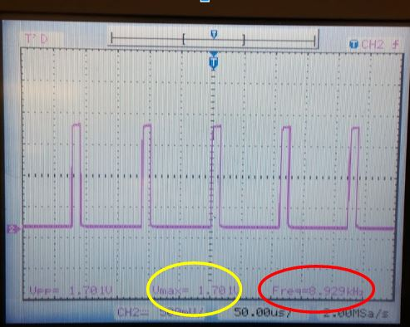

Figure 1.16: Oscilloscope output of Comparator Circuit.

HS-422 DELUXE SERVO MOTOR

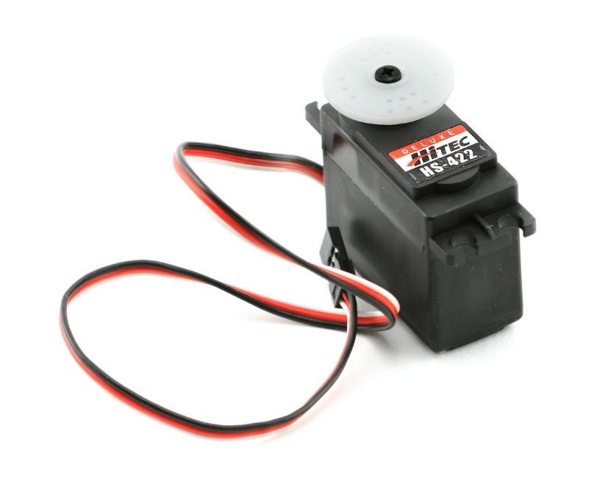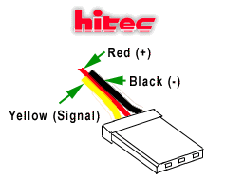

Figure 1.18: Wiring structure of HS-422

Figure 1.17: HS-422 Servo Motor

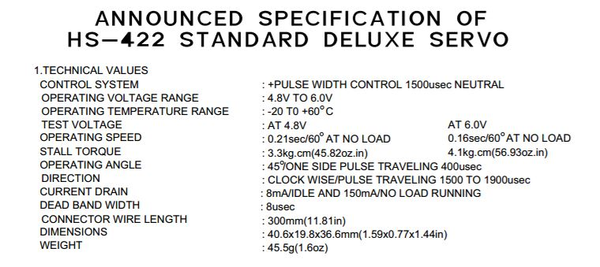

Figure 1.17: Specifications of Servo Motor from datasheet

The HS-422 servo motor has three separate connections; the red positive wire, the black negative wire and the yellow signal wire. The servo expects a pulse at a rate of 50 Hz in order to gain correct information about the angle. The width of the pulse dictates the range of the servo's angular motion. One end position requires 1ms pulses the opposite end position requires 2ms pulses. Sending 1.5ms pulse sets the servo motor to the center position. The servo motor was added to the project to facilitate sound source location using angles. The servo motor with microphones mounted on it continuously swept the playing field for a signal source. An identified location caused the rover to turn in the direction of the source, based on the direction of the servo motor and the angle provided by the module. It was powered by PMOD pins on the BASYS Board.

INDUCTIVE SENSING CIRCUIT

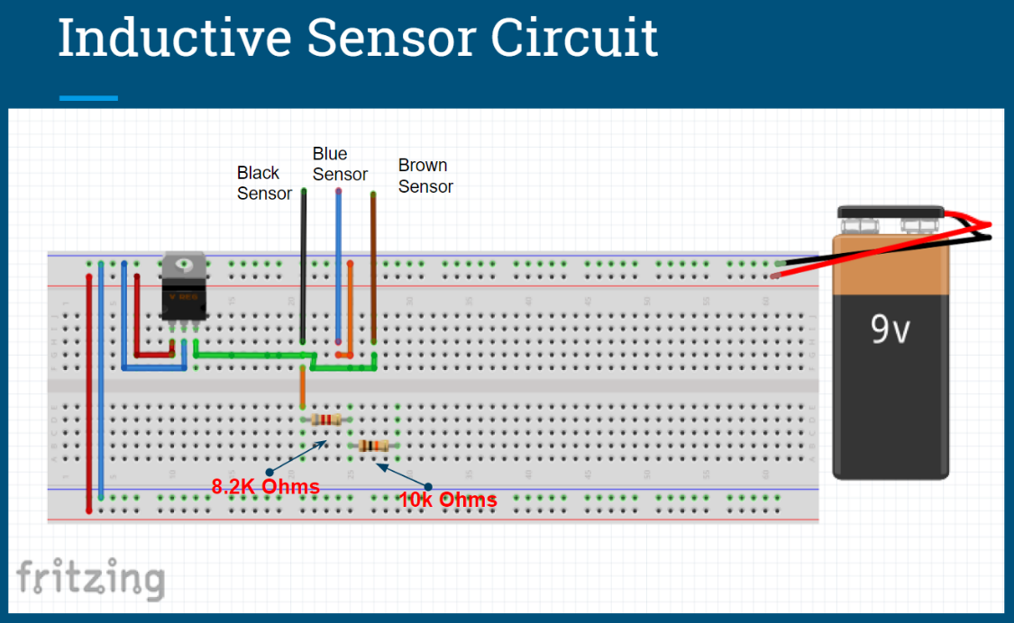

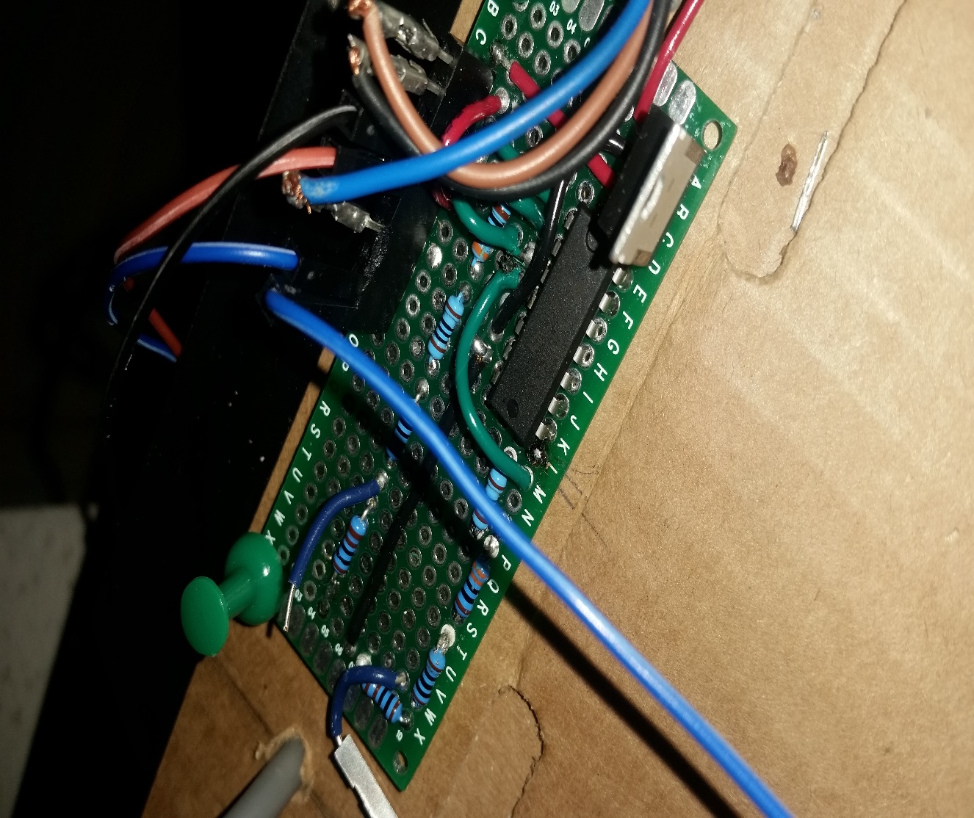**v**

Figure 1.19: Final Soldered IPS Circuit

Figure 1.18: Inductive sensor circuit designed using Fritzing

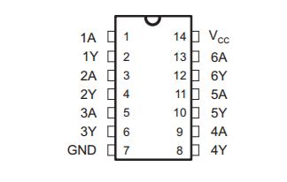The inductive sensor circuit was made up of two LJ18A3-8-Z/BX 8mm Approach Sensor Inductive Proximity sensors (see Figure 1.21) connected to a NOT Gate. Since the signal voltage of the sensor drops when metallic tape is within the 8mm range, a NOT gate was used to invert its output. The inverted output was split using a voltage divider. The resistors used were 530 Ω and 110 Ω,

Figure 1.20: SN74HC04 Inverting IC

LED CIRCUIT

The LED Circuit consisted of three sets of red, blue and green LEDs. Each LED in a set was connected to a 100 ῼ resistor. Each set was powered by a separate PMOD connector on the BASYS Board.

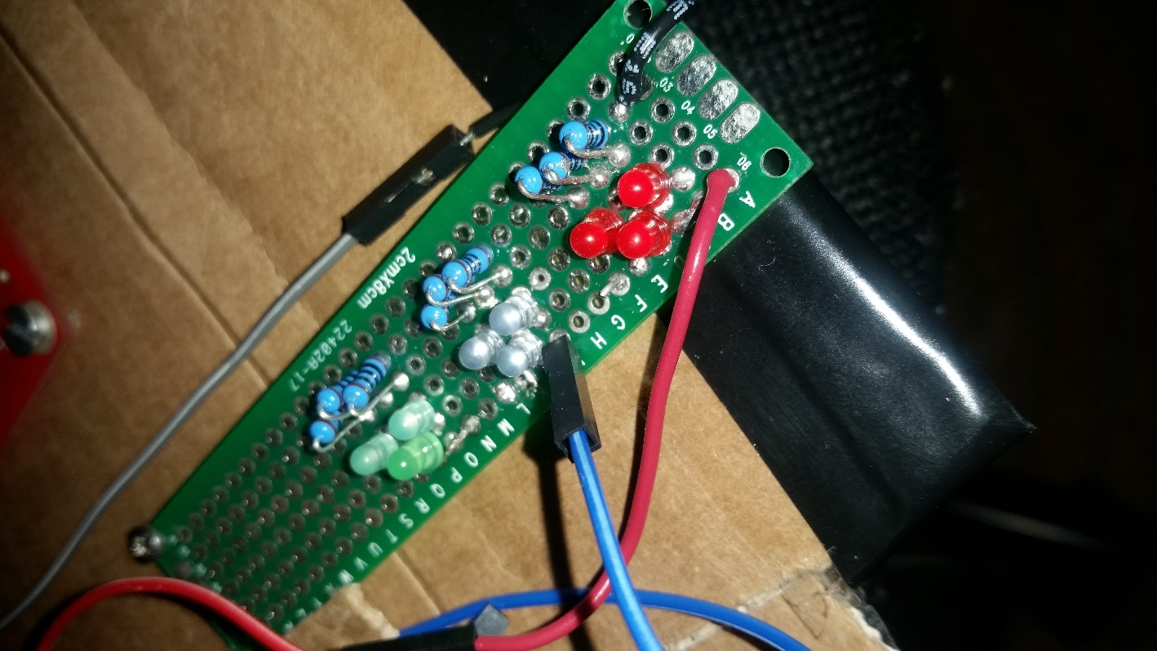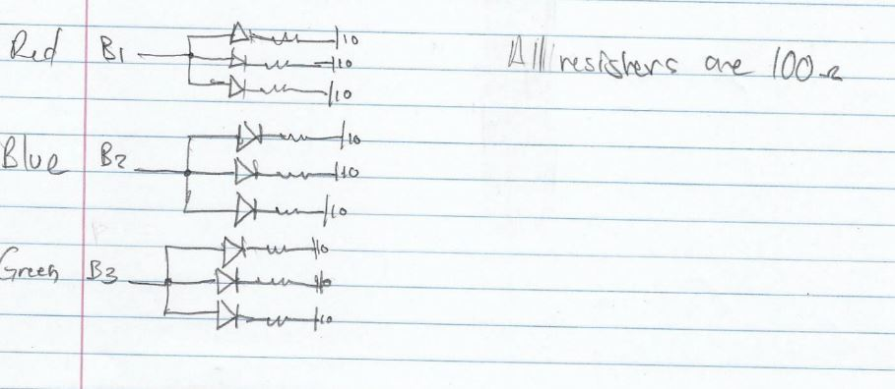

Figure 1.22: Soldered LED Circuit

Figure 1.21: Sketch of LED Circuit set-up

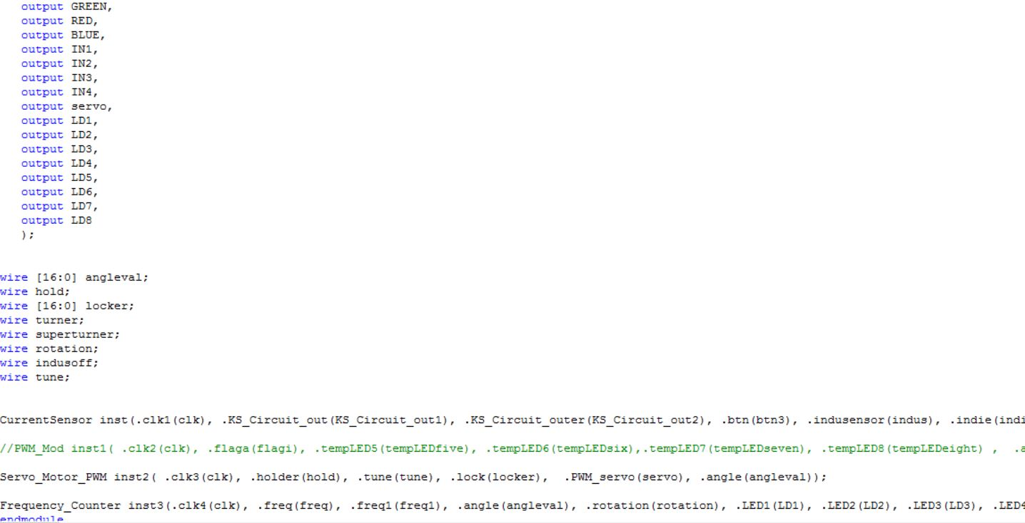PULSE WIDTH MODULATION FOR MOTOR MOVEMENT

Figure 2.1: Mother Module Coordinating All Parts

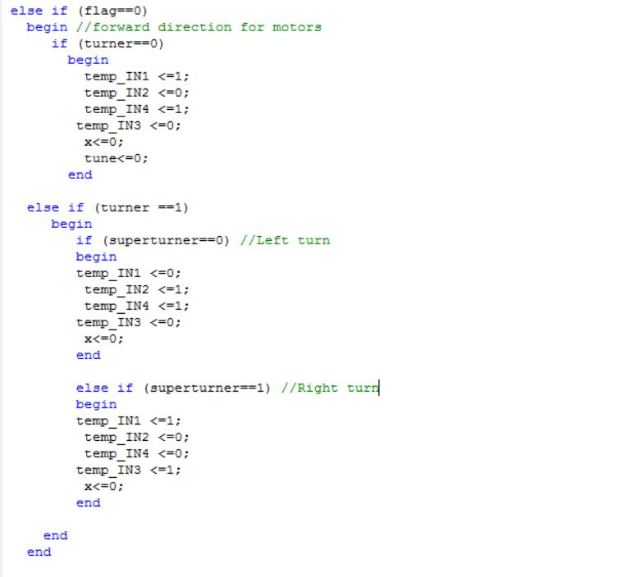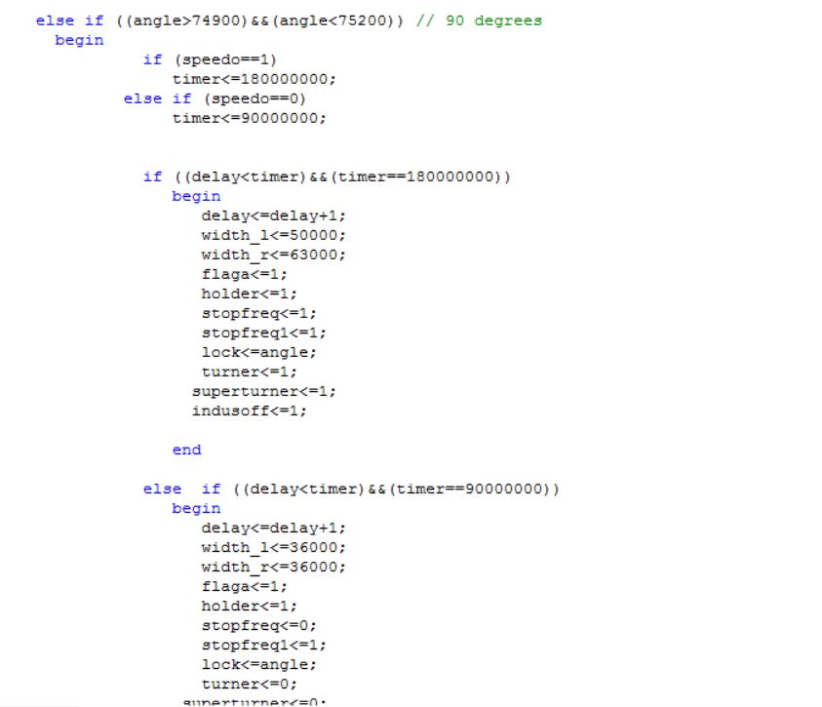

Figure 2.3: Inputs Controlling Directions of Motors

Figure 2.2: Duty Cycles

The main module shown in Figure 2.1 had every single module “wired” through it. This was vital in the allocation of roles for various hardware parts that would be used by two separate modules. The two motors of Wall-E needed to be configured to aid the sound localization process. An appropriate PWM value for speed was required to effectively move on carpeted floor with fully-functional changes in direction. Wall-E only responded to sounds with frequencies within the ones stated above. A 55% duty cycle was appropriate for forward movement, while 90% or above was required for turns (Figure 2.2). Multiple modules were used to control movement of the motors. The inputs controlling motor direction were called from the Current Sensing Module via flags and output registers (Figure 2.3). Verilog always requires one signal driving one output, hence that was the most effective way of controlling motor movement.

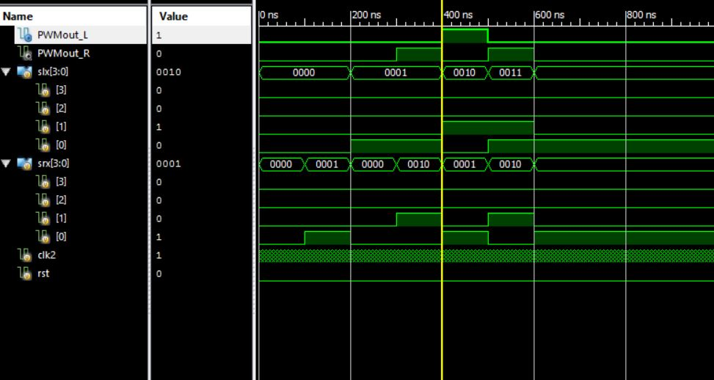

Figure 2.4: Test Bench for Duty Cycles

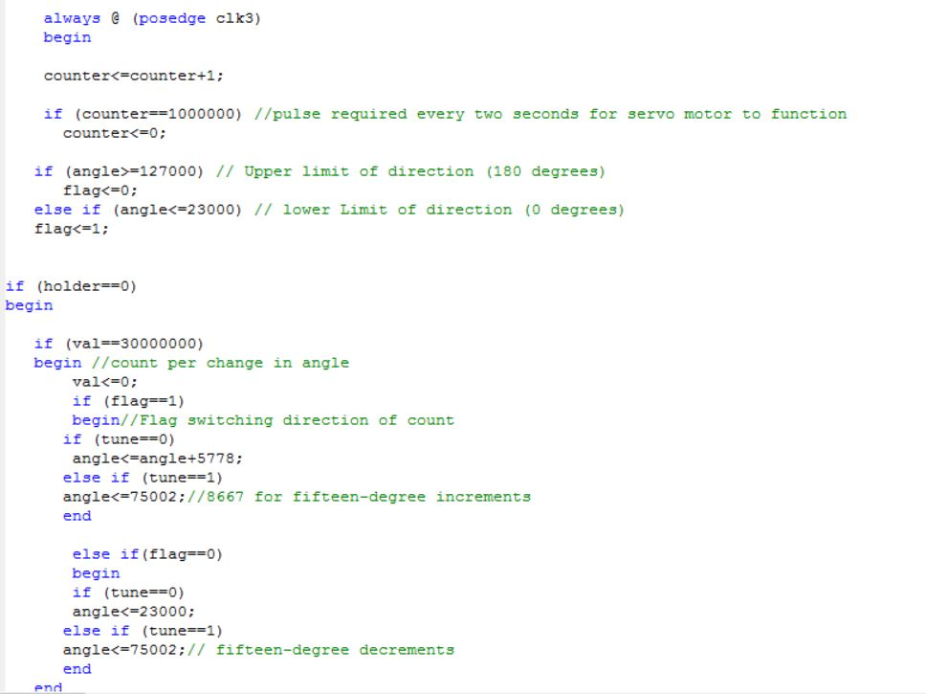PULSE WIDTH MODULATION FOR HS-422 SERVO MOTOR

Figure 2.5: Counter cycle for Servo Motor Working with Microphones

The Servo Motor required a separate PWM module to operate. The range of 1ms to 2ms were altered by a separate register. The servo motor was synchronized to work with the other modules by “holding” the servo motor in position when the microphone was in phase with the source of signal. Using a trial and error method, the PWM value corresponding to the angle 0° was found to be the 17-bit value 23000, while the angle 180° had a value of 127000. The servo motor would throw itself to angle 90° after an angled turn was completed. For an angled turn, the servo PWM for a particular angle was sent to a motor movement module, where a delayed turn was used depending on the particular direction the microphone. After reaching the angle 180°, the servo motor resets itself to the 0° angle position and begins the increments again.

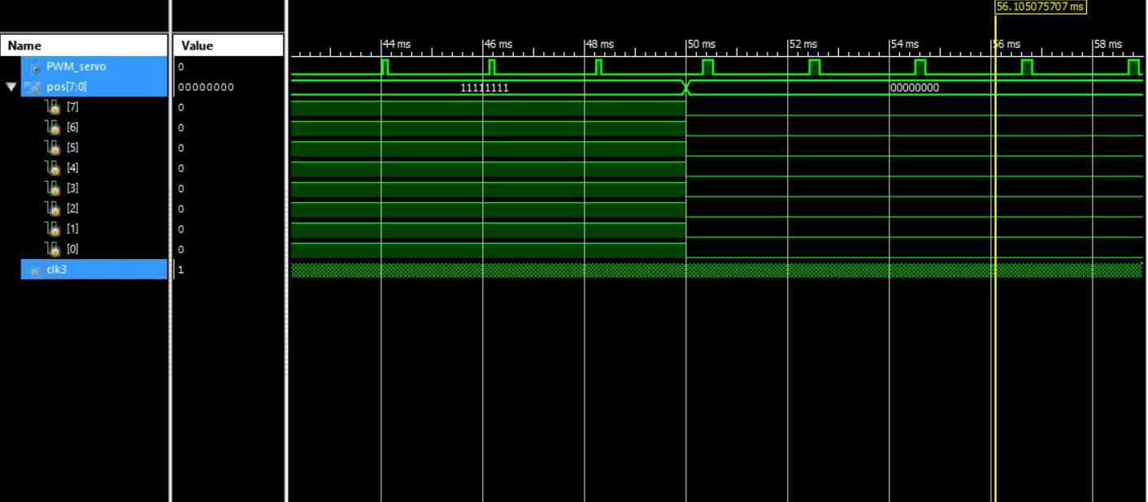

Figure 2.6: Largest and Smallest PWM for Servo Motor

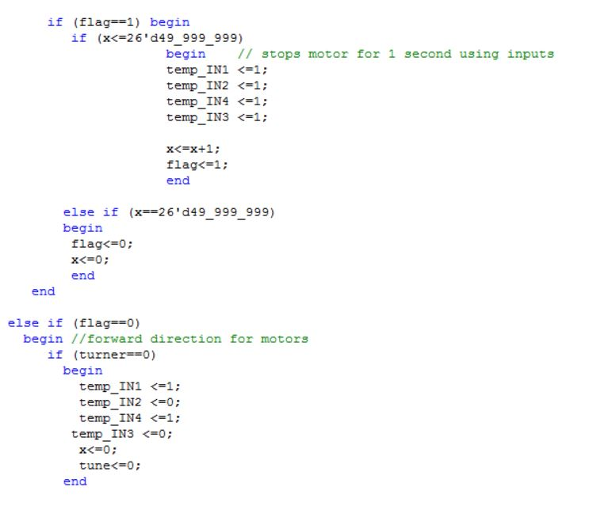CURRENT SENSING MODULE

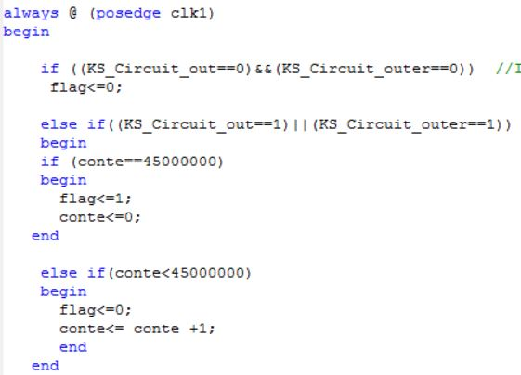

Figure 2.8: Timed Delay for Current Spike

Figure 2.7: One second Delay for motor

The current sensing module was required to stop the motors for one second whenever the current reaching any of the motors exceeded 1 ampere. The registers “KS_Circuit_out” and “KS_Circuit_outer” represented the Current Senses A and B respectively from the H-Bridge Circuit. Since the response involved the two inputs for each motor, portions of the motor movement were synchronized with the current detector module. A major part of the current-sensing module involved making provision for the current spikes that occur when a motor is initially turned on. This problem was addressed using the counter “conte” which made sure a current surge ensued for 0.9 seconds before the motors were stopped. The inductive sensing module was also embedded in the current sensing code to improve compatibility.

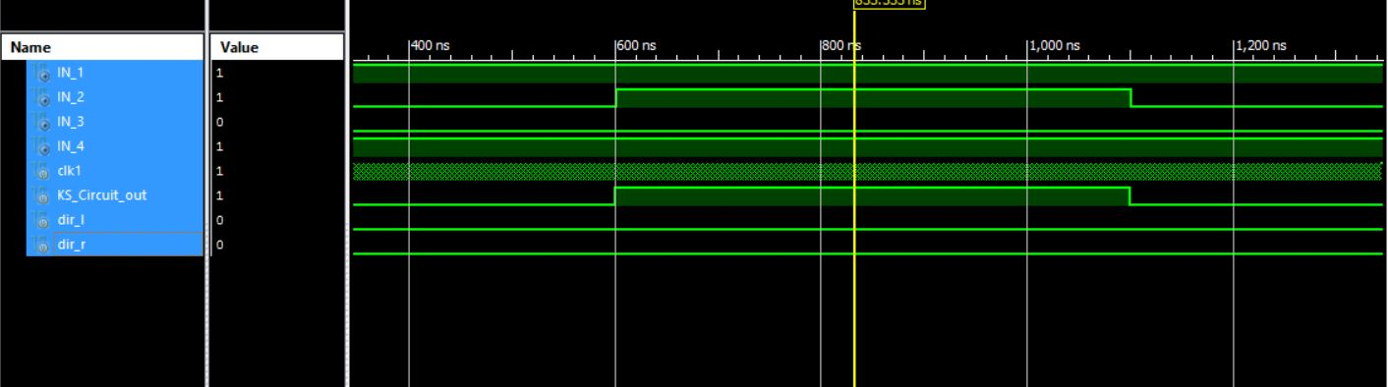

Figure 2.9: Test bench for Current Sensing

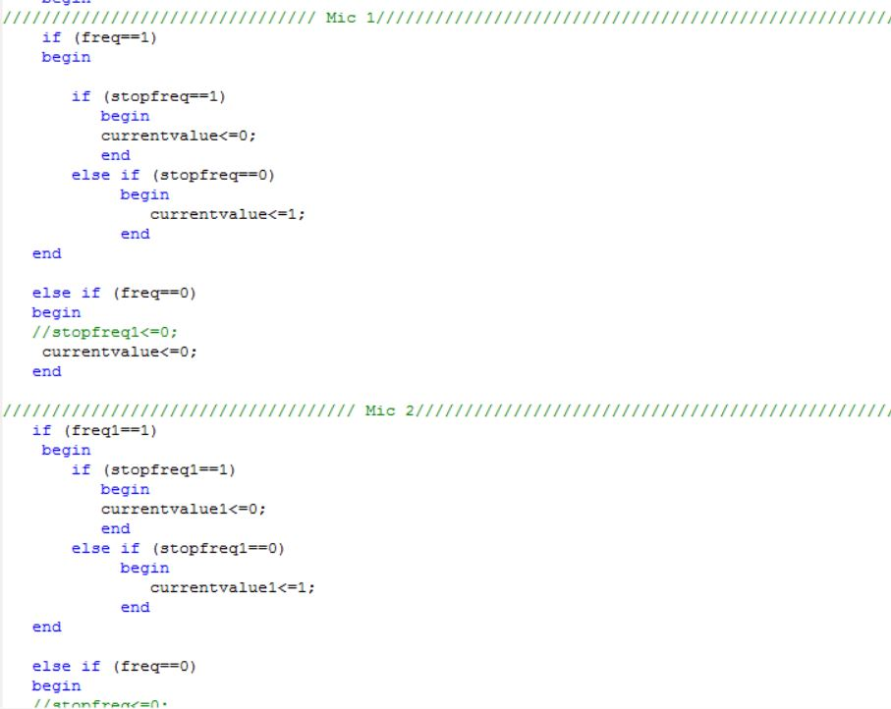SOUND LOCALIZATION MODULE

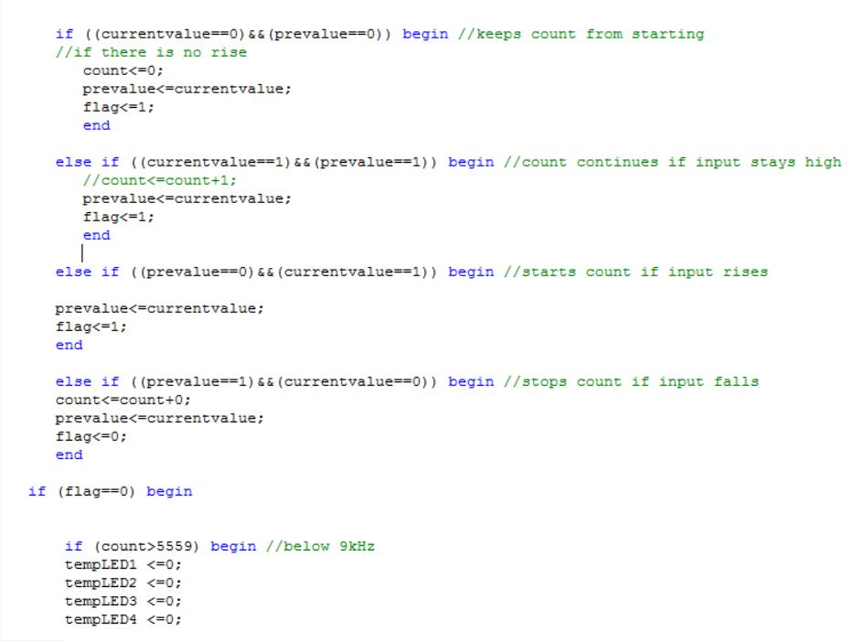

Figure 2.11: Rising Edge Part II

Figure 2.10: Rising Edge Section of Code

The sound localization module was divided into three main components. Namely:

1. Frequency Filtering & Identification

The frequency filtering was read into the BASYS Board using the lines of code shown in Figure 2.10 and Figure 2.11. The count value would start with a rising edge and stop with a drop. The counts for each input were assessed with if-else statements (Figure 2.12). In order to prevent frequencies from getting mixed up, an extra filter was used, as well as LED lights on the BASYS Board.

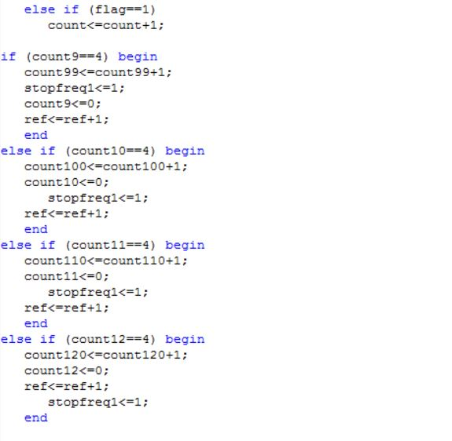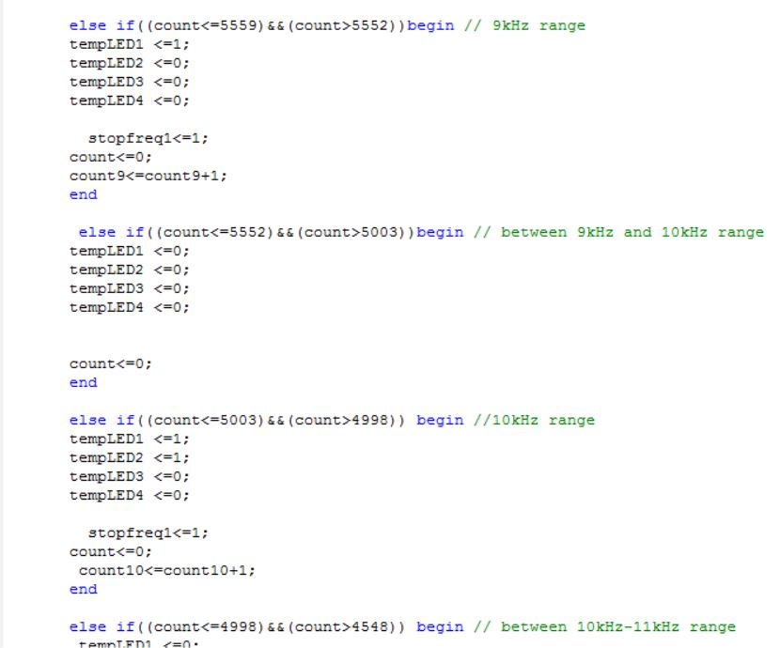

Figure 2.12: Cases for each Frequency Count

Figure 2.13: Filtering Sequence for Mic 1

1. Motor Movement

Motor movement was allowed only if a frequency within the specified ranges was being received by the BASYS Board. It was initialized by a flag only turned on by a post-filter LED turned on for a few milliseconds. Motor movement worked in conjunction with the servo motor by using several cases pertaining to angles reached by the servo. Hence, every single movement was decided by the position of the servo motor. Delays were added to lengthen or decrease the degree of turns for every case. The 90° angle was the only that enable forward movement.

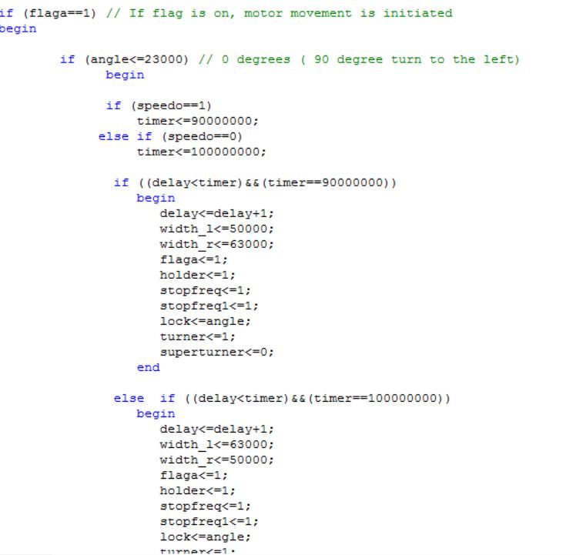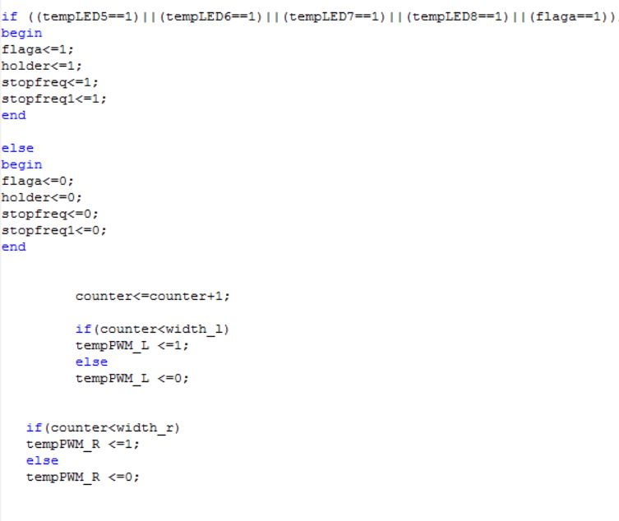

Figure 2.14: Motor Movement Initialization

Figure 2.15: Example of 0° Angle

The speedo flags were used in the case of two microphones. If the rear microphone obtained a signal before the front one, Wall-E would do 180° turn (Figure 2.15).

1. LED Identification Module

The LED Identification Portion of the Sound Localization module was simply used to fulfil the frequency recognition portion of the original rubric. The code was quite simple; after each motor movement, a counter was incremented by 1, with each specific frequency having a separate counter register. After the limit was reached by the main counter (spot==100), the values for each frequency were compared. The highest one enabled the assigned LED to turn on for 5 seconds.

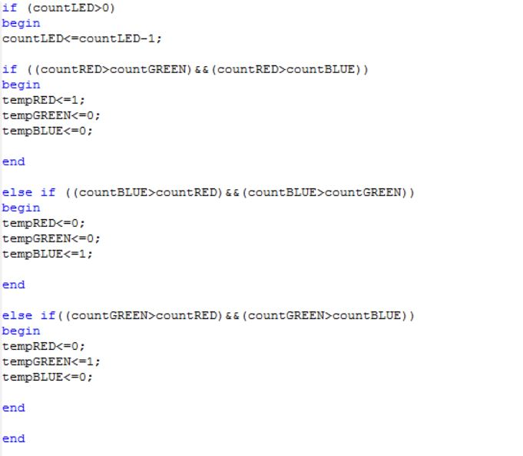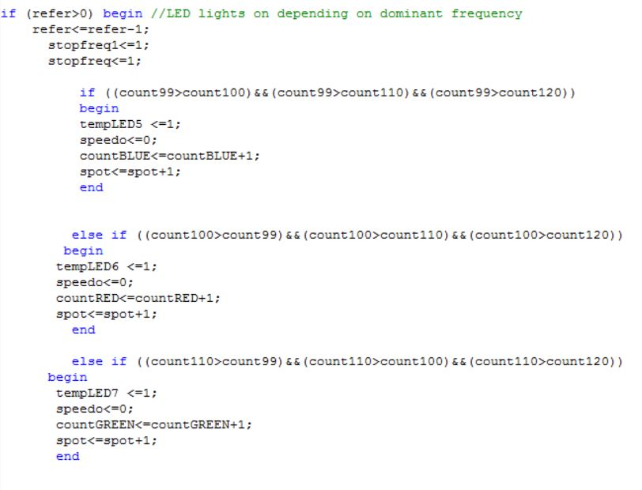

Figure 2.17: LED Filter and Display

Figure 2.16: LED Count

INDUCTIVE SENSING MODULE

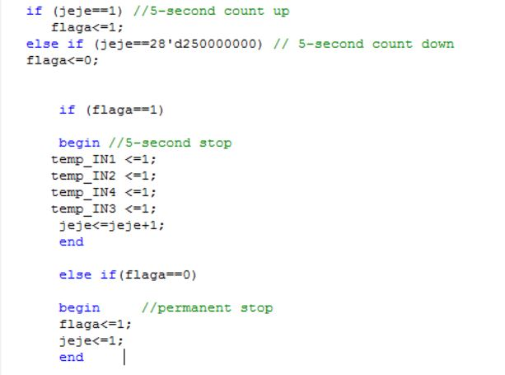The inductive sensing module was embedded in the current sensing module to, as stated previously, improve compatibility. Once the inductive sensors were activated, the Inputs 1-4 were assigned ones to completely halt motor movement. There was no movement until an assigned pushbutton was pressed to rotate the rover.

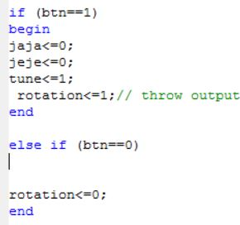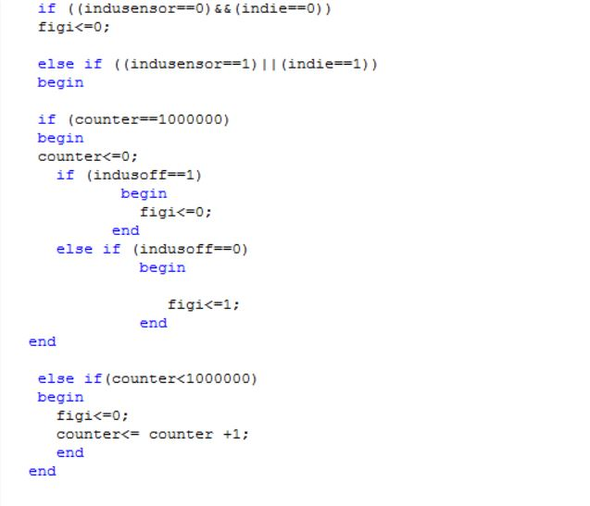

Figure 2.20: Push Button Action after Inductive Sensing

Figure 2.19: Routine for Left or Right Inductive Sensor

Figure 2.18: Stop routine for Inductive sensors

RESULTS

By the end of the project, several technical lessons were learned. The project group many setbacks, including power distribution problems on the demonstration day. In spite of all these challenges faced, the team satisfied some requirements of the project’s rubric. They were:

1. Frequency identification using LED circuit.
2. Autonomous movement in direction of sound source.
3. Current Surge Detection
4. Inductive sensing

The biggest issue faced at the time of demonstration was the range of reception. That was down to the gain on the sound circuit.

**CONCLUSION**

Wall-E was able to accomplish the sound localization aspect of the project with a different method. By utilizing the servo motor, this team applied a makeshift servo system of sound localization that would have proved to be more efficient than the phase difference method every other project group applied.

Similar to the radar system used by aircrafts, the servo motor system has direct applications to many real life scenarios. When natural disasters or accidents occur, the time taken to locate injured victims and provide immediate care often directly affects the death toll. A more efficient Wall-E could identify locations of victims for rescue workers in one sweep. As I continue to say, the possibilities are endless.

**REFERENCES**

* Rover 5 Datasheet <https://www.sparkfun.com/datasheets/Robotics/Rover%205%20Introduction.pdf>
* LMx58-N Low-Power, Dual-Operational Amplifiers

<http://www.ti.com/lit/ds/symlink/lm158-n.pdf>

* HS-422 Servo Motor

<https://www.servocity.com/hs-422-servo>

* Announced Specification of HS-422 Standard Deluxe Servo

<http://cdn.sparkfun.com/datasheets/Robotics/hs422-31422S.pdf>

* Sound Circuit Summary by Binh Le

<https://drive.google.com/open?id=0B4uTwcgIzTGPeWJVb3BLOHZ3WU9jMFpYNXB5VXhCd0djS3l3>

APPENDICES

1. 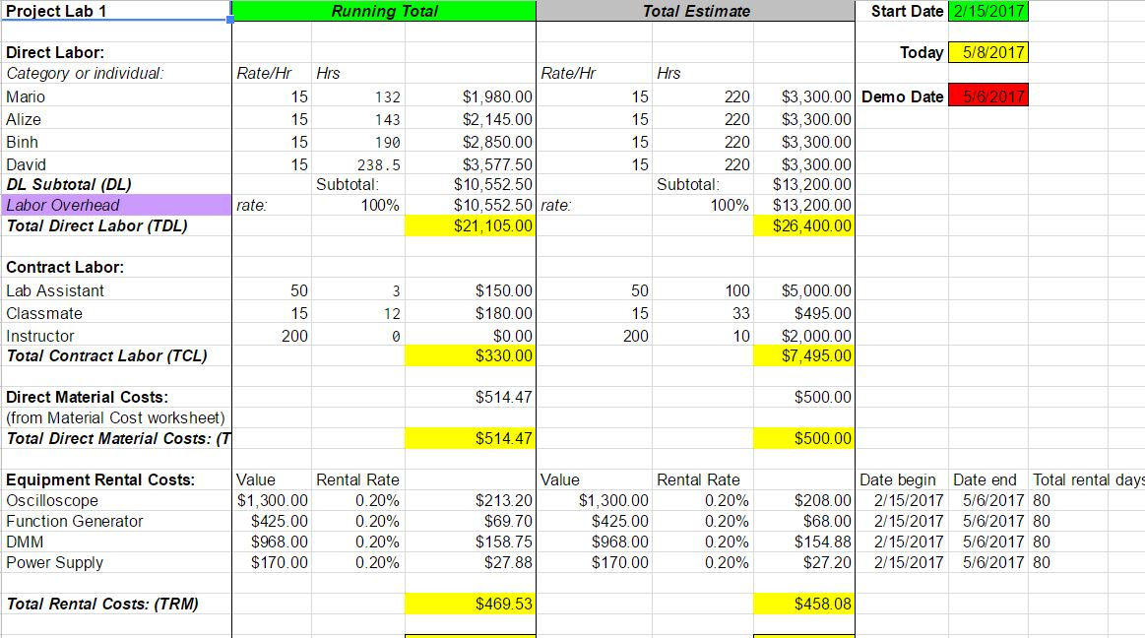Budget

We were well below our projected budget, and used less funding than we anticipated by the end of the project. A primary factor was finding cost-effective and recycled alternatives for materials. All but one member of project group failed to reach the projected number of labor hours. This also reduced out running total by the end of Demo Day.

1. Material Costs
2. 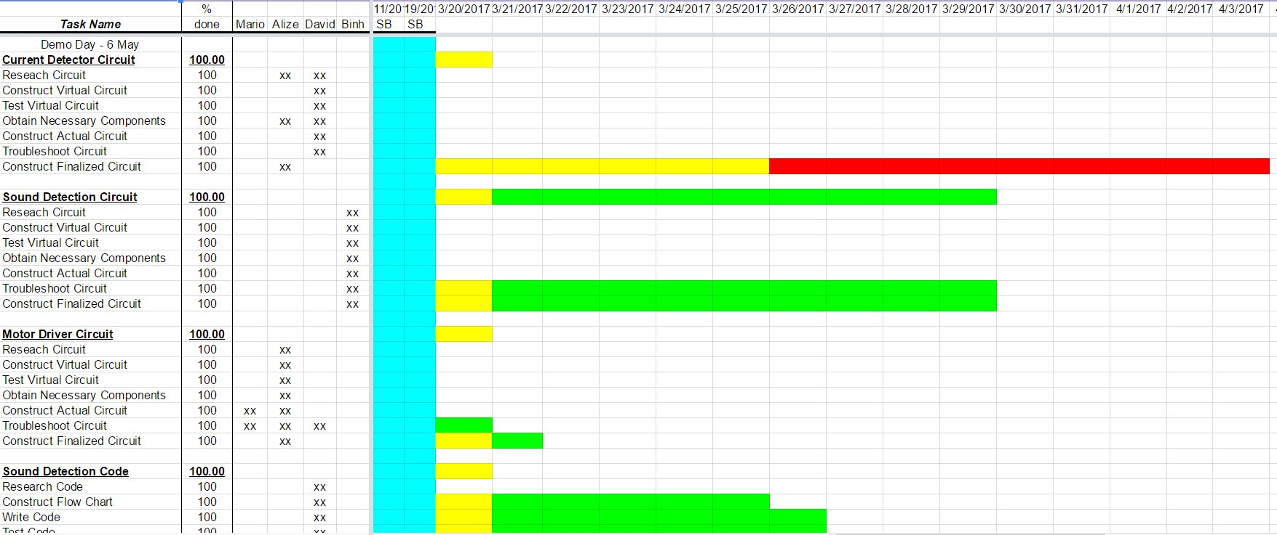Gantt Chart

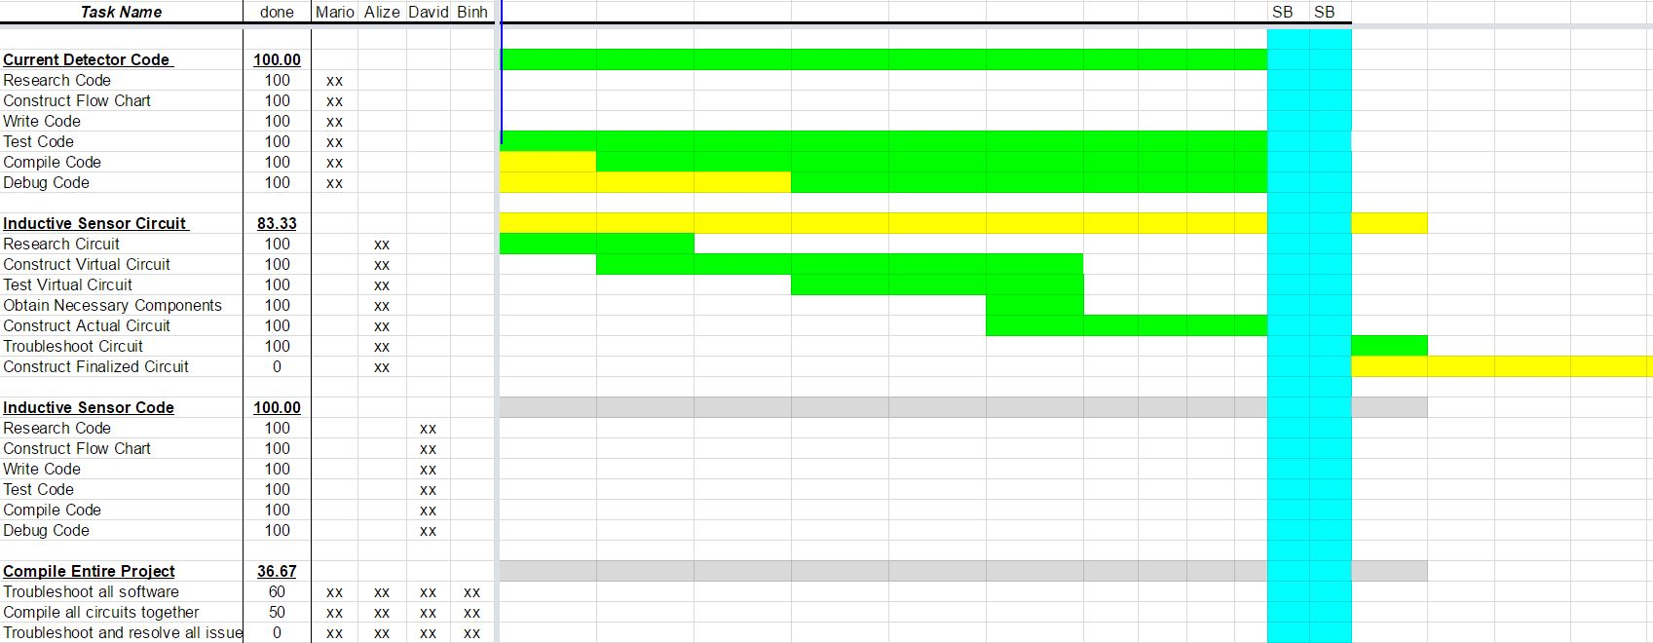

The Gantt chart reflects the trouble faced with the PCB current detector Circuit. It also shows how compiling the project was poorly accomplished. Overall, a better job could have been done with meeting schedules.

1. Additional Links

Verilog Modules:

<https://drive.google.com/open?id=0B4uTwcgIzTGPSWVfMk05cFdEbGM>

Pre-Demo Day Run:

<https://drive.google.com/open?id=0Bz4tCyfIMYHfU3QxTnZEcUY2U0E>